John Henry Kipp, Sr.
And Children
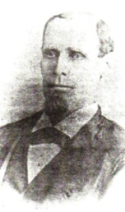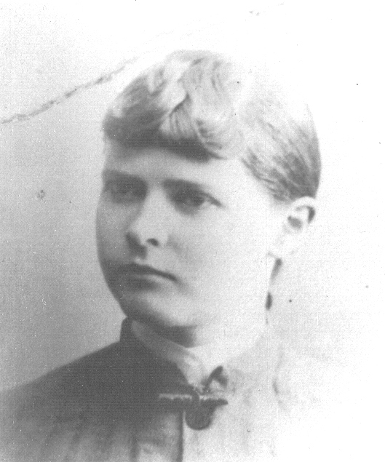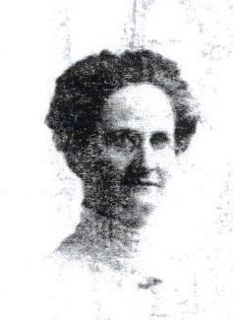
John Henry John Henry Mary Ophelia Ida Irene Kipp
Kipp, Sr Kipp, Jr. Kipp Burlingham
1842-1924 1870-1941 1872-1891 1874-1959
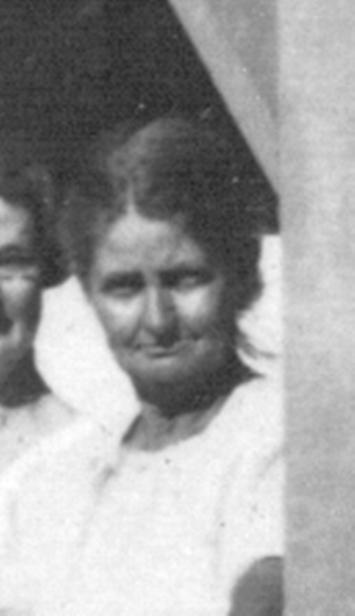 Ellen Jane Kipp 
Emma Elizabeth Kipp March 18, 1979 Alice Florence Kipp
Settle Before 1900 Butcher
1876-1957 1881-1951
Laura Justice Kipp 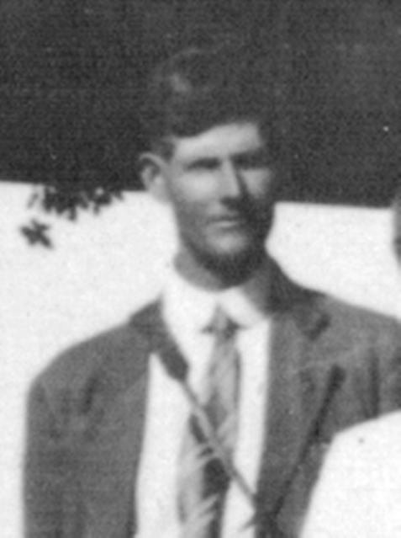 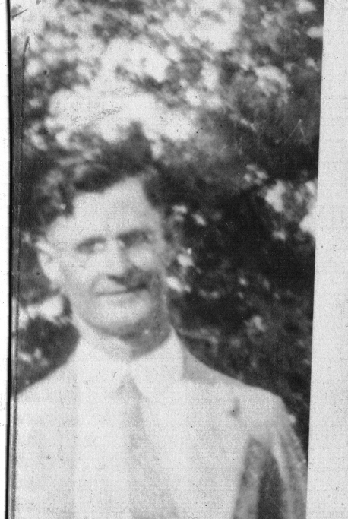
May 22, 1885 William George Eli Jackson
February 9, 1887 Kipp Kipp
1887-1939 1890-1978

