Abraham Kipp and Children

Abraham Henry Kipp John Henry Kipp, Sr.
Son of Jane Henry Smith Kipp
1806-1880 1842-1924

Daughters of Elizabeth Scobey Justice Kipp

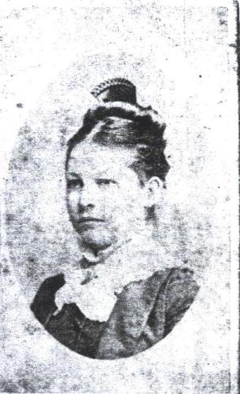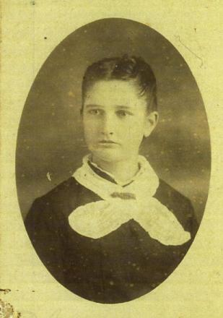

Alice Frances Kipp Florence Sofelia Kipp
1862-1886 1868

